Build a Histogram

A histogram is a chart that displays the shape of a distribution. A histogram looks like a bar chart but groups values for a continuous measure into ranges, or bins.

The basic building blocks for a histogram are as follows:

|  |  |
| --- | --- |
| **Mark type**: | Automatic |
| **Rows shelf**: | Continuous measure (aggregated by Count or Count Distinct) |
| **Columns shelf**: | Bin (continuous or discrete).  ***Note****: This bin should be created from the continuous measure on the Rows shelf. For more information on how to create a bin from a continuous measure, see*[*Create Bins from a Continuous Measure*](https://onlinehelp.tableau.com/current/pro/desktop/en-us/calculations_bins.html)*.* |

In Tableau you can create a histogram using **Show Me**.

1. Connect to the **Sample - Superstore** data source.
2. Drag **Quantity**to **Columns**.
3. Click **Show Me** on the toolbar, then select the histogram chart type.

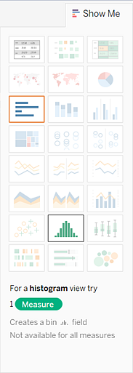

The histogram chart type is available in **Show Me** when the view contains a single measure and no dimensions.

Three things happen after you click the histogram icon in **Show Me**:

* + The view changes to show vertical bars, with a continuous x-axis (1 – 14) and a continuous y-axis (0 – 5,000).
  + The **Quantity** measure you placed on the **Columns** shelf, which had been aggregated as SUM, is replaced by a continuous **Quantity (bin)** dimension. (The green color of the field on the **Columns** shelf indicates that the field is continuous.)

To edit this bin: In the Data pane, under Dimensions, right-click the bin and select **Edit**.

* + The **Quantity** measure moves to the **Rows** shelf and the aggregation changes from SUM to CNT (Count).

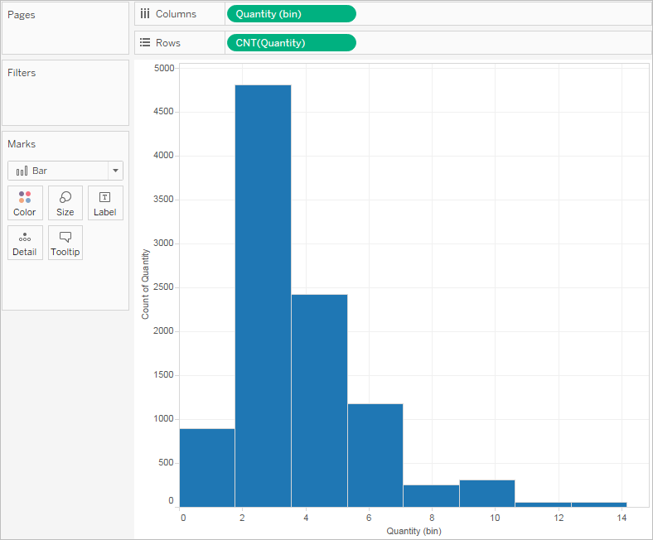

The **Quantity** measure captures the number of items in a particular order. The histogram shows that about 4,800 orders contained two items (the second bar), about 2,400 orders contained 4 items (the third bar), and so on.

Let's take this view one step further and add **Segment** to **Color** to see if we can detect a relationship between the customer segment (consumer, corporate, or home office) and the quantity of items per order.

1. Drag **Segment**to **Color**.

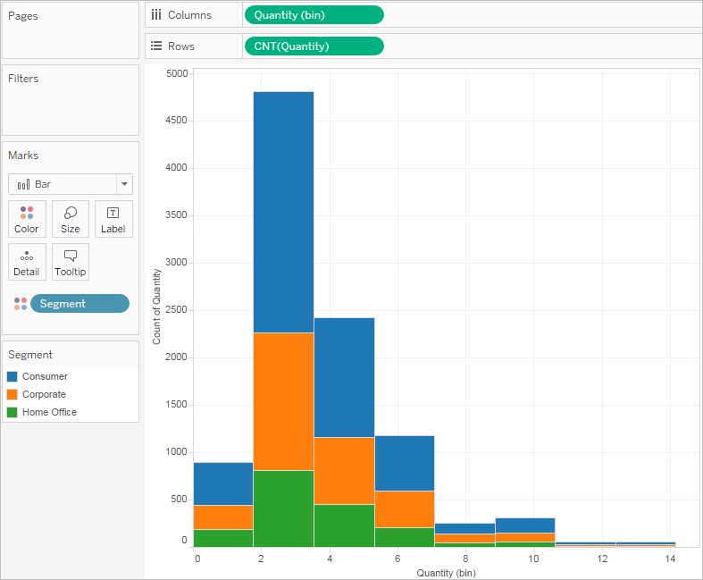

The colors don't show a clear trend. Let's show the percentage of each bar that belongs to each segment.

1. Hold down the Ctrl key and drag the **CNT(Quantity)** field from the **Rows** shelf to **Label**.

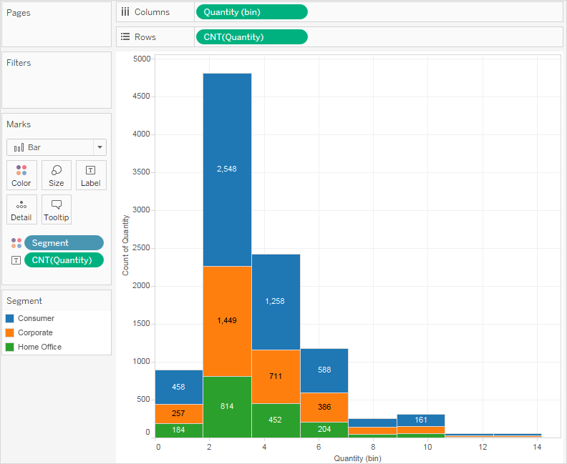

Holding down the Ctrl key copies the field to the new location without removing it from the original location.

1. Right-click (Control-click on a Mac) the **CNT(Quantity)** field on the **Marks** card and select **Quick Table Calculation** > **Percent of Total**.

Now each colored section of each bar shows its respective percentage of the total quantity:

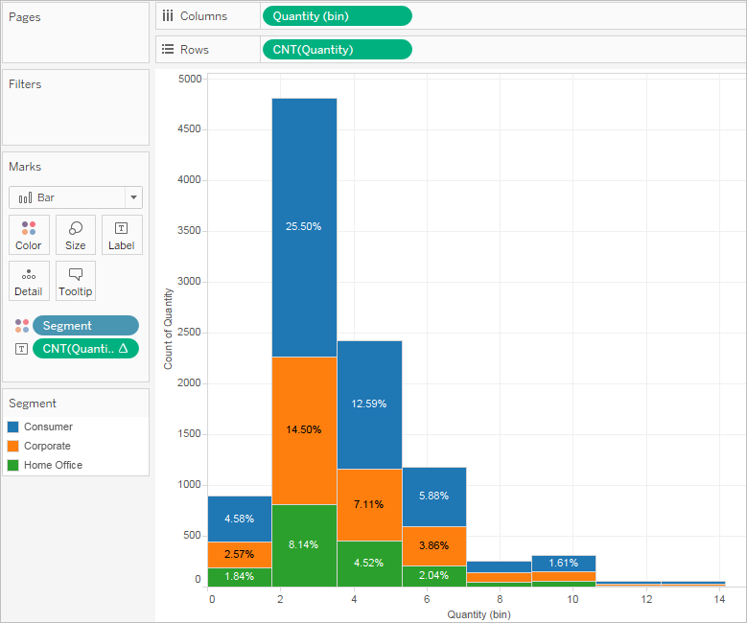

But we want the percentages to be on a per-bar basis.

1. Right-click the **CNT(Quantity)** field on the **Marks** card again and select **Edit Table Calculation**.
2. In the Table Calculation dialog box, change the value of the **Compute Using** field to **Cell**.

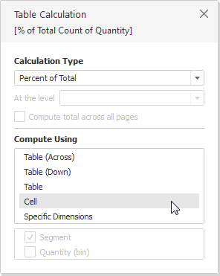

Now we have the view that we want:

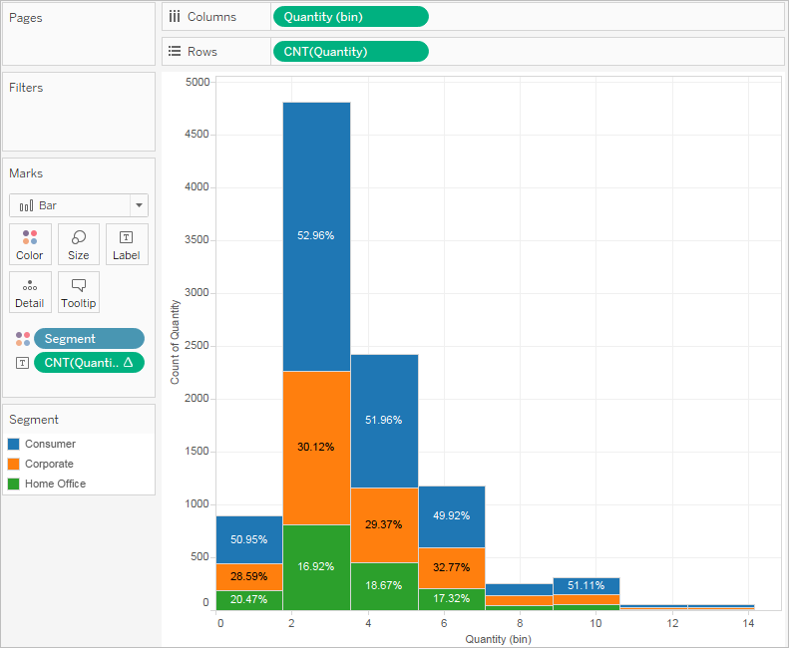

There is still no evidence that the percentages by customer segment show any trend as the number of items in an order increases.